Experiment 8
Devops lab
Chaudhary Tuba
231410
TE IT

Aim: to execute docker commands in docker desktop

- docker –version : gives the version of the docker.
- docker images – give the names and ID’s of the already present images.
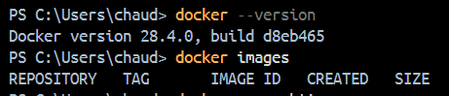

- docker info – give all the information about the installed docker.
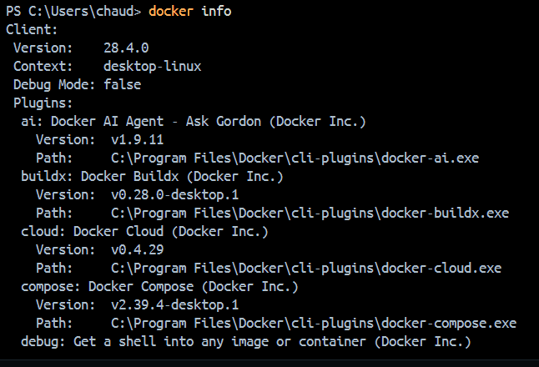

- docker help – lists all the docker commands
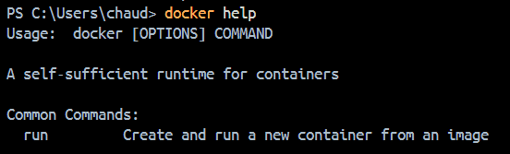
- docker ps –- Lists all running containers on your system.

- docker run python -- Runs a new container from the Python image and executes its default command.
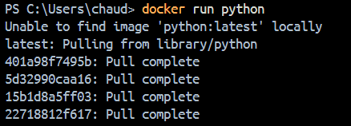

- docker run -it python:3.12 -- Runs a new container from the Python 3.12 image in interactive mode with a terminal, letting you use the Python shell.
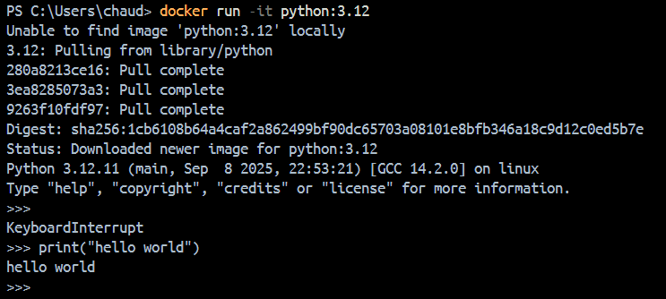

- docker ai ask “Explain containerization” -- Docker AI Agent (experimental, for AI-related tasks).
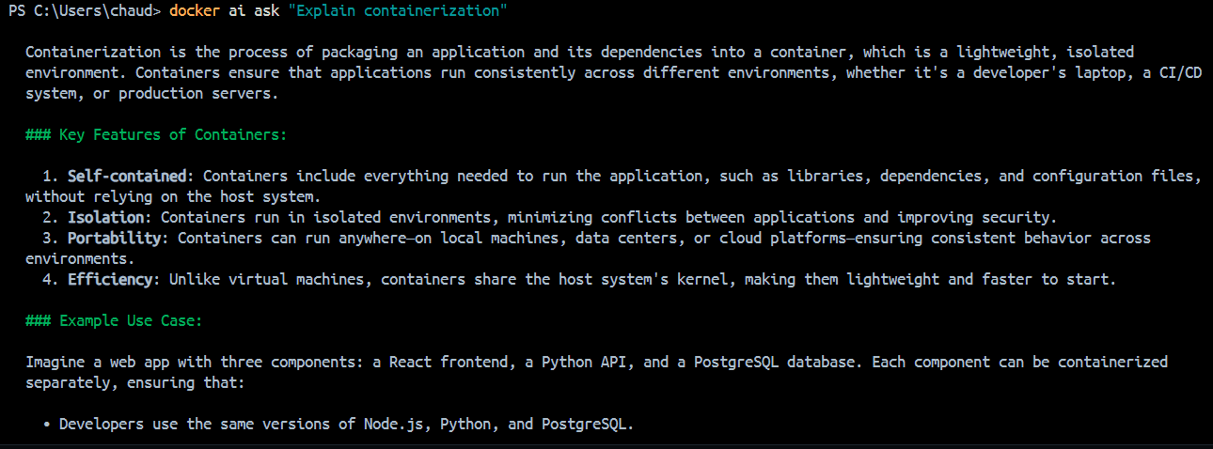

- docker login -- Log in to a Docker registry (like Docker Hub)
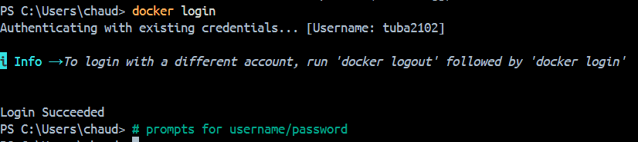

10.docker push – Upload a Docker image to a registry.
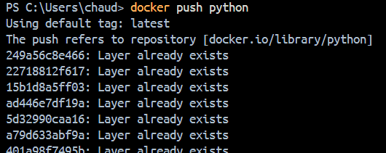

11.docker rmi php – deletes the image

12. docker inspect python -- Display detailed information on one model.
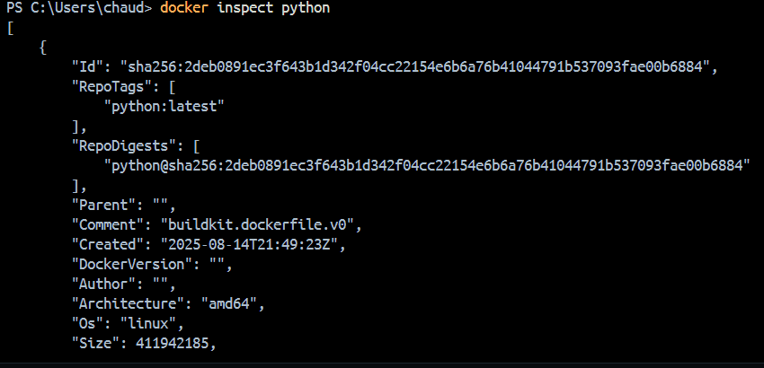

13. docker builder ls – Lists all Docker builder instances and shows their status and details.
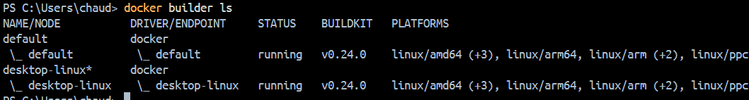

14. docker cloud -- Manages Docker Cloud services and resources from the command line.
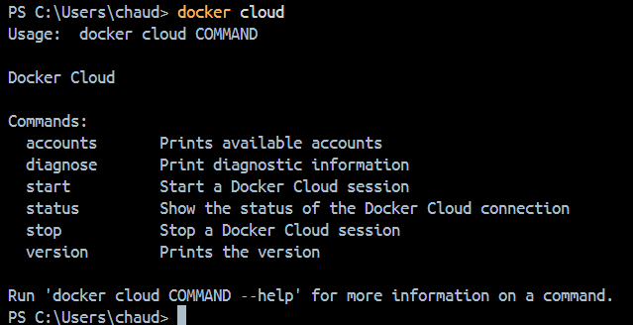

15. docker sbom python:3.12 -- Generates and shows a Software Bill of Materials (SBOM) for the python:3.12 image, listing all included packages.
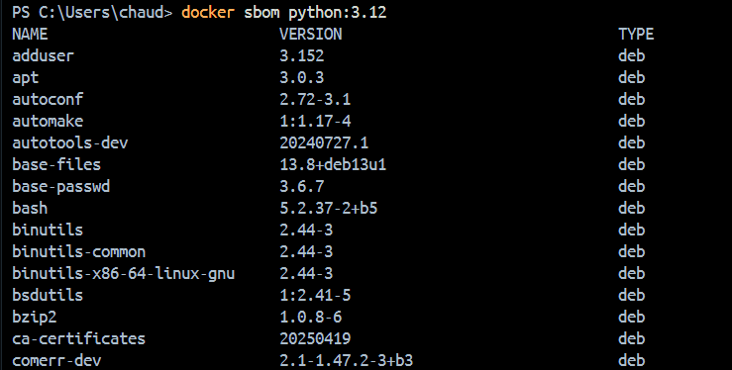

16. docker volume ls –- Lists all Docker volumes on the system.
